BUSINESS INTELLIGENCE REPORT
Customer Behaviour & Revenue Optimization

Analyst: [laxmi Narayan badatia] | Tools: Python (Pandas/SQL Alchemy), SQL, Power BI
Data Scope: 5,000 Global Customer Records
1. Executive Summary
This end-to-end data project identifies high-growth opportunities within the retail sector. By architecting a data pipeline from raw CSV ingestion to interactive visualization, the analysis uncovered that Electronics and the 51+ age demographic are the primary revenue engines, contributing over 40% of total sales. The report concludes with targeted strategies to address a 75% revenue decline observed in the Fall quarter.

2. Business Objective
The project was initiated to solve three core business challenges:
- Operational Efficiency: Standardize disparate transactional data for accurate reporting.
- Customer Segmentation: Identify which demographics (Age, Gender, Location) yield the highest Lifetime Value (LTV).
- Strategic Growth: Determine seasonal and category-based trends to optimize marketing spend

3. The Technical Pipeline (Methodology)
I. Data Engineering & Cleaning (Python)
- Library Stack: Pandas for manipulation, Matplotlib for EDA, and SQLAlchemy for database ingestion.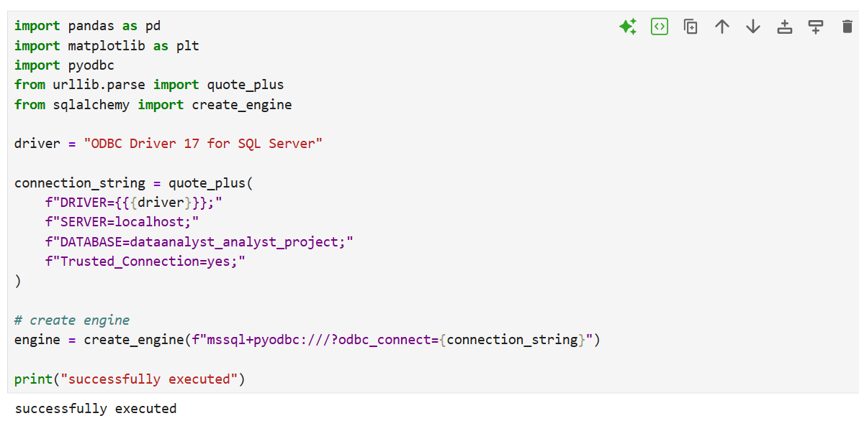
- Sanitization: Handled missing "Review Ratings" and standardized "Purchase Amounts" to ensure float consistency.
- Handled missing "Review Ratings"
- 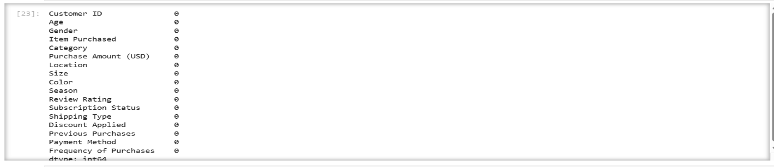
- standardized "Purchase Amounts" to ensure float consistency.
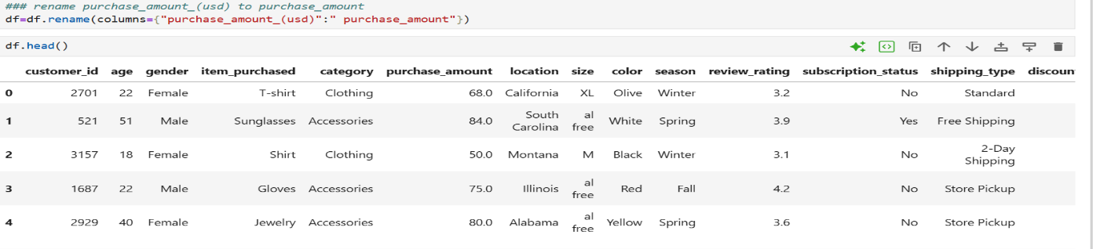
- Schema Mapping: Transformed raw product names into five high-level categories (Electronics, Clothing, Footwear, etc.) to allow for executive-level aggregation.
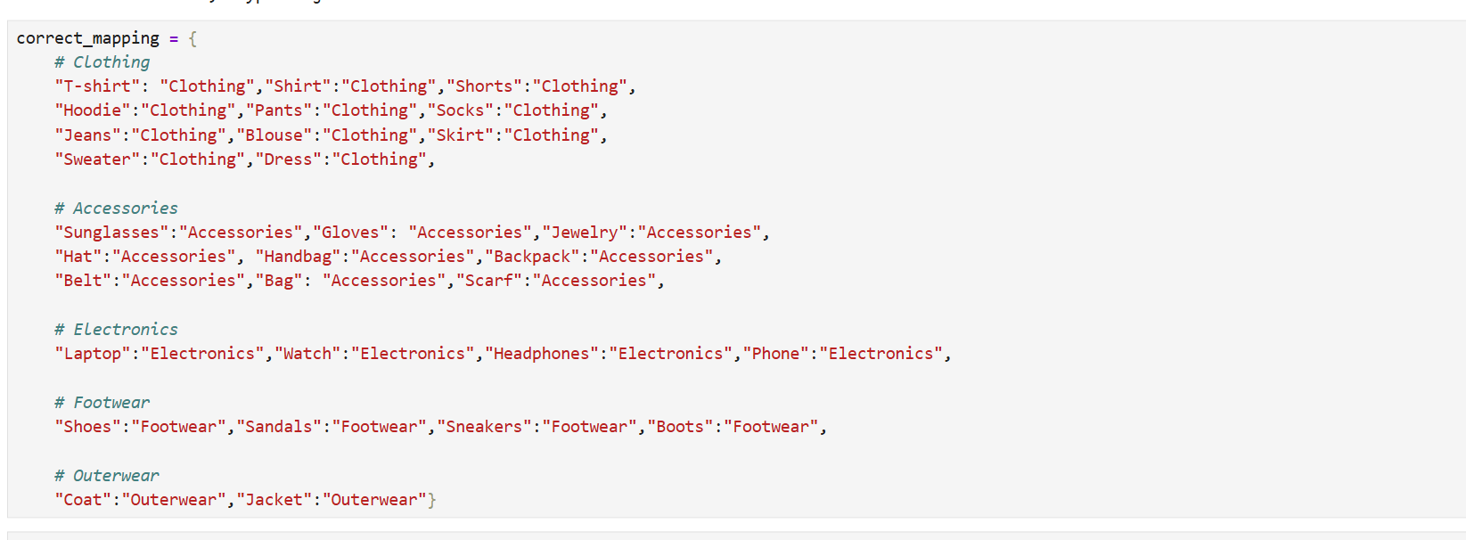
- Database Load: Automated the export of the cleaned dataset into an SQL environment for relational querying.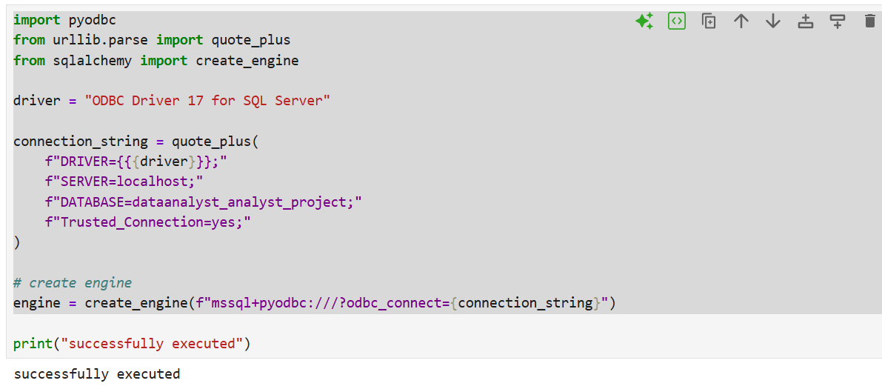
II. Business Logic & KPIs (SQL)
Advanced SQL queries were utilized to extract complex metrics that standard reporting tools cannot always handle:
- Regional Benchmarking: Ranked cities by Total Spend vs. Average Order Value (AOV).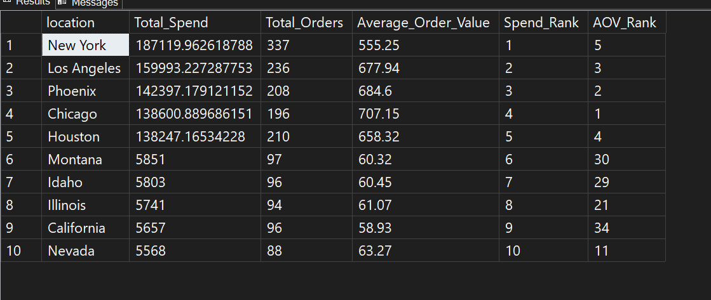
- the revenue contribution of each age group

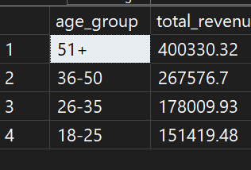

III. Visual Intelligence (Power BI)
A dynamic dashboard was developed to provide "At-a-Glance" decision-making capabilities. Key features include:
- Interactive Slicers: Filter by Gender, Category, and Season.
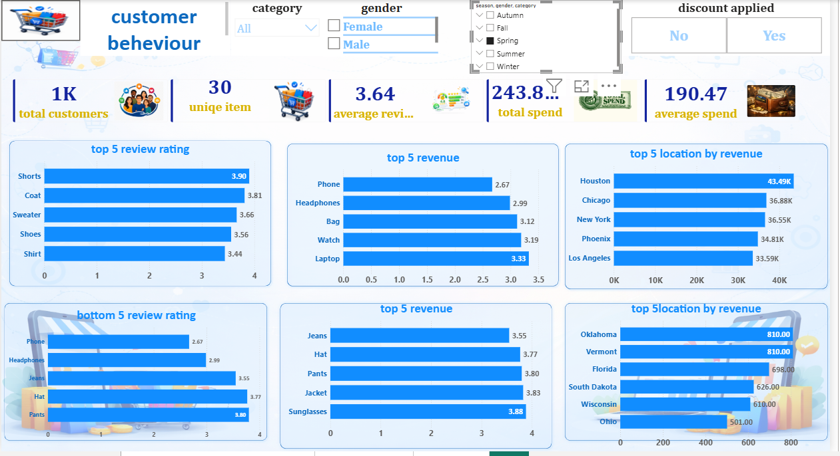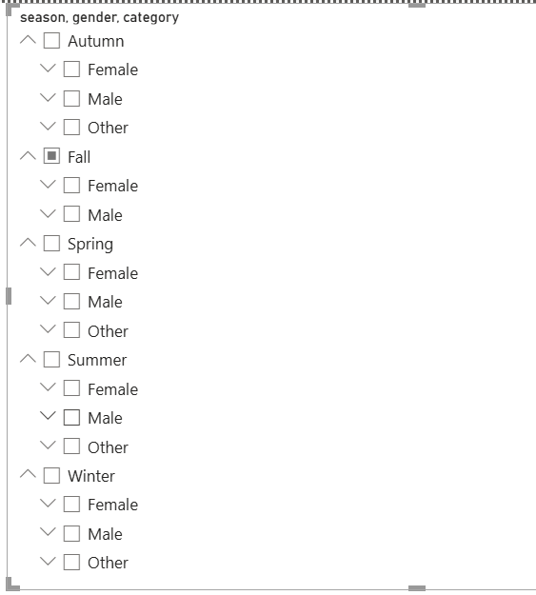

- Revenue Heatmaps: Visualizing geographic high-performers (e.g., New York and Los Angeles).
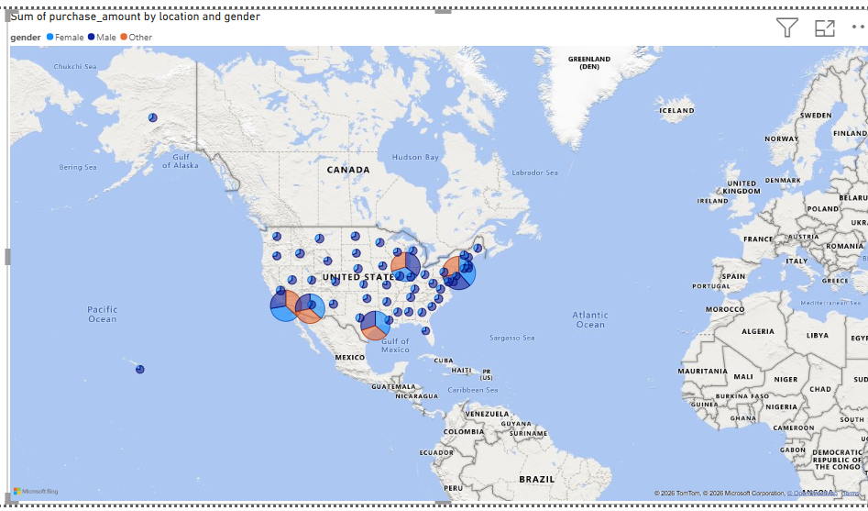

4. Key Performance Indicators (KPIs)
Metric | Value | Business Status
Total Revenue | $997.3K | High Growth
Active Customer Base | 5,000 | Stable
Average Order Value (AOV) | $197.49 | Premium Positioning
Customer Satisfaction | 3.62 / 5.0 | Needs Optimization

5. Strategic Insights & Findings
- The "Power Demographic": Customers aged 51 and older are the most lucrative segment, generating $400.33K (40.1%) of total revenue.

- Category Dominance: The Electronics category outperformed all other sectors, accounting for nearly 50% of total spend ($0.49M).
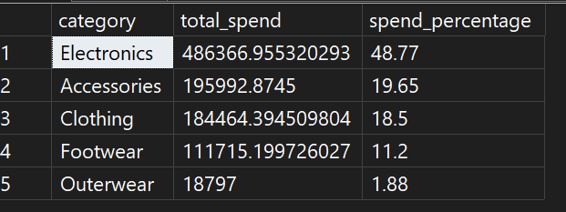
- Seasonal Risk: A critical "Revenue Gap" exists in the Fall Season. While other seasons average $240K, Fall drops to $61K, indicating a lack of seasonal engagement or product relevance.
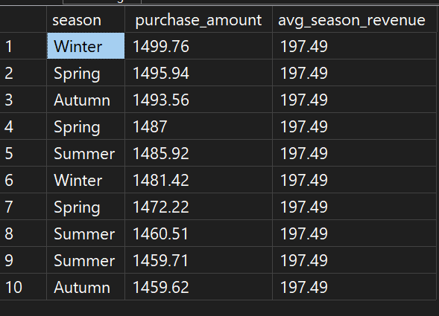
- Payment Behavior: Debit Cards are the preferred method of transaction ($254K), suggesting a customer base that prefers immediate liquidity over credit.
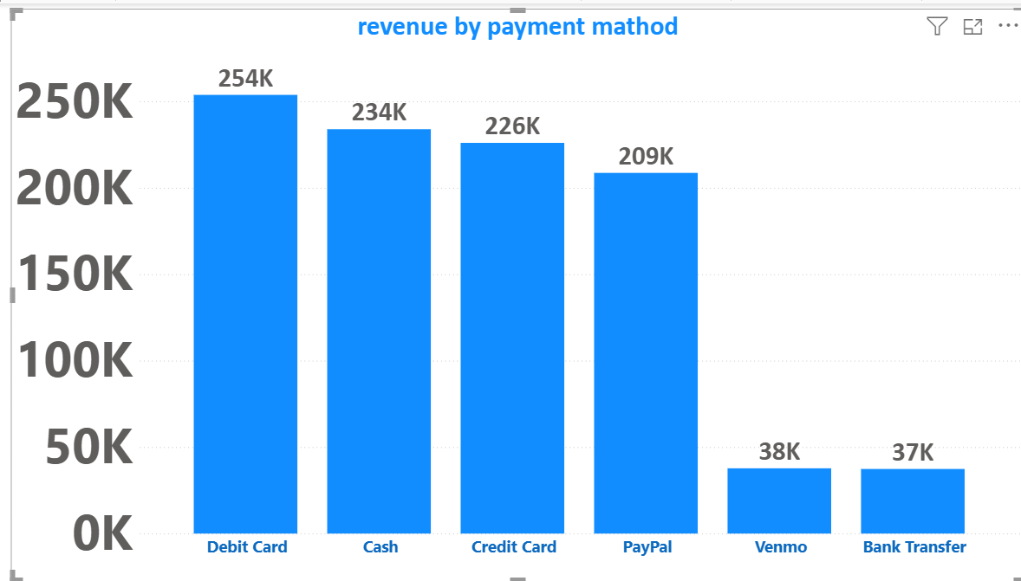

6. Actionable Recommendations
- Retention Campaign: Launch a "VIP Loyalty Program" specifically for the 51+ age group to protect the 40% revenue core.
- Fall "Bridge" Strategy: Introduce "Pre-Winter" or "End-of-Summer" sales events to mitigate the 75% revenue drop-off currently seen in the Fall quarter.
- Regional Scaling: Increase the digital marketing budget for New York ($187K) and Los Angeles ($160K), as these regions show the highest conversion velocity.
- Service Quality Improvement: With a 3.6 rating, the business should implement a post-purchase survey triggered by the SQL database to identify friction points in the "Accessories" category.
7. Conclusion
This project demonstrates the ability to translate raw data into a strategic roadmap. By utilizing a robust technical stack (Python/SQL/Power BI), we have moved from "observing data" to "predicting growth." Implementing the recommendations above will stabilize seasonal volatility and capitalize on high-performing demographics.

